- Yes, I'm looking for that style, "dark steel" color with brown wood for handling.
- What is your recommendation?
- I'm maybe too maniatic, but I'm looking for a gas blowback 1911, full metal (excluding the wooden parts) and with a good weight (1000 g at least).
- Thank you in advance, and sorry for my non perfect english.
- RandomRiceFarmer
— 24/08/2020 17:59
May I have a picture example?
- 1911s by default do not have wooden handles
- If you are referring to the color, than they do
- RandomRiceFarmer
— 24/08/2020 18:09
https://www.airsoftmegastore.com/index.php?route=product/product&product_id=23165
- The “wooden” grips on 1911s are made from Bakelite wood (not real)
- https://www.kyairsoft.com/accessories/airsoft-peripherals/we-grips/we-1911-wood-grips.html
WE - 1911 Wood Grips - WE - Grips - Airsoft Peripherals - Accessories
Your one stop repair parts station, Factory original spare parts, upgrade reinforced parts, airsoft model 1:1 replica and more!!
- Cat — 24/08/2020 22:02
I meant that the handle can be wooden (i dont care) , I have seen some 1911 with that part made of wood (real and airsoft ones).
- Yeah, I was talking about that kind of grips.
- The one in your picture look sharp, ¿is that the one that you are recommending me?
- Wait, ¿is it the real firearm?
- Oh, no, is a airsoft one. Just realised the text was there.
- It looks awesome. Did you painted it (to give it a realistic touch)?
- RandomRiceFarmer
— 24/08/2020 22:12
It’s a KJW M1911A1
- It came with orange tip but I sanded it down
- Cat — 24/08/2020 22:12
Yeah, I've just saw it on the official page.
- RandomRiceFarmer
— 24/08/2020 22:13
Also I didn’t paint it, I just used and it has that natural looking wear
- Cat — 24/08/2020 22:13
I think i saw the same one, but can you send me the link, please?
- Really? It looks better!
- RandomRiceFarmer
— 24/08/2020 22:14
https://www.evike.com/products/28054/
Evike.com
KJW M1911-A1 Gas Blowback Pistol (Model: Green Gas)
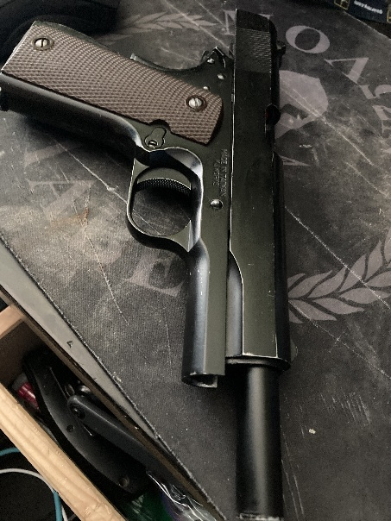

- Same one
- It’s probably due to it being used often
- I just disassemble it, drop it by accident, fire it, and the usual stuff you would do
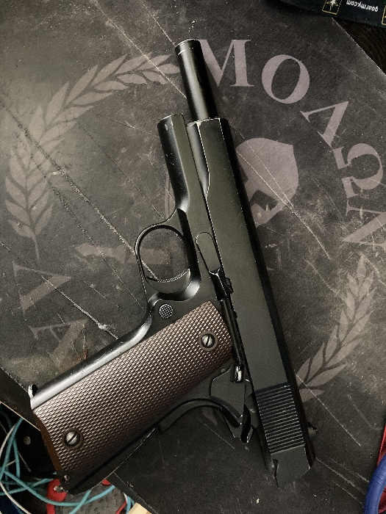
- https://www.evike.com/products/28804/
Evike.com
KJW 25 Round Magazine for KJW 1911 Gas Blowback Airsoft Pistols (Co...

- Spare magazines
- RandomRiceFarmer
— 24/08/2020 22:22
If you’re wondering how I got the magazine to look worn, I just take it in and out of the magazine all the time
- Cat — 24/08/2020 22:30
Yeah, i thought thay would be the solution. Thank you! I also appreciate that the link is from evike.com, it is a good page.
- But one last question, how many years have your pistol?
- RandomRiceFarmer
— 24/08/2020 22:34
5 years
- Played with it for 2
- Cat — 24/08/2020 22:47
Oh so it is strong.
- I know I said last question, and sorry for bother, but what aboit accuracy, range and blowback (how does it operate, in general).
- RandomRiceFarmer
— 24/08/2020 22:48
It operates well
- Most of it is metal, except for a plastic HopUp
- But that’s covering inside the slide
- I’ve never tried shooting further than than 20 meters since I have a rifle for that
- Cat — 24/08/2020 22:51
Sounds well, thank you. The plastic hopup piece doesnt matter.
- Thank you so much. You were so nice. You found the perfect replica.
- RandomRiceFarmer
— 24/08/2020 22:51
You can replace it with something stronger
- Cat — 24/08/2020 22:52
Oh, so it is open for upgrades. Did you do that?
- RandomRiceFarmer
— 24/08/2020 22:52
Ya, it’s a Tokyo Mauri copy
- So it’s open to upgrades
- I never upgraded mine since I’m content with it
- Cat — 24/08/2020 22:55
Thank for your recommendation. I will probably buy it next year. I'll probably tell you when i have it.
- Does green gas work well with it?
- And wich size of bb's?
- RandomRiceFarmer
— 24/08/2020 22:56
.20
- And there’s 2 versions
- Cat — 24/08/2020 22:56
Sorry again... Forgot about that.
- Ok.
- RandomRiceFarmer
— 24/08/2020 22:56
You can pick
- The green gas version has a more natural looking magazines
- Cat — 24/08/2020 22:57
Oh, ok. Thank you!
- Cat — 04/09/2020 12:38
Hi again. And sorry for bothering you again. But I don't have clear which brand i should choose for bbs and green gas.
- RandomRiceFarmer
— 05/09/2020 6:28
BLS is well known for their high quality BB's and is one of the biggest airsoft BB manufactures (there are only a few in the world). All the top BB brands will come from this same factory. BLS have their own branded BB's but below is a list of BB brands that are made by BLS. Best BB Brands: - BLS - Elite Force - ASG Blasters - Nuprol - KWA - Valken - EMG - G&G - Krytac - Madbull - Specna Arms Edge What BB's to avoid: Anything not on the list above is 99% of the time not recommended unless they are OEM'd by BLS. Avoid anything cheap and never use .12g as they can damage your gun.
- Whatever green gas you want
- I'm personally not a snob about it
- Cat — 05/09/2020 11:54
Allright! Thanks!

